**Employee Attrition Analysis Dashboard Report**

Date: [9th August 2024]

Author: [Archita Sharma]

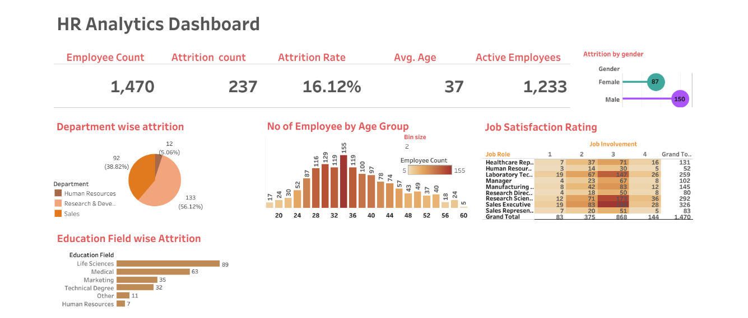

**1. Overview**

The HR Analytics Dashboard provides an insightful overview of key metrics related to employee attrition within the organization. The dashboard is divided into several sections, each focusing on different aspects of the employee population, attrition, and satisfaction levels. Below is a detailed analysis of the various sections presented in the dashboard.

**2. Key Metrics**

* **Employee Count:** The total number of employees is 1,470.
* **Attrition Count:** The organization has seen an attrition of 237 employees.
* **Attrition Rate:** The attrition rate stands at 16.12%.
* **Average Age:** The average age of the employees is 37 years.
* **Active Employees:** There are 1,233 active employees in the organization.

**3. Attrition by Gender**

* **Female:** 87 females have left the organization.
* **Male:** 150 males have left the organization.

The higher number of male employees leaving indicates a potential area for further analysis to understand the underlying reasons.

**4. Department-wise Attrition**

The attrition is spread across various departments, with the following distribution:

* **Research & Development:** 133 employees (56.12%) have left this department, making it the highest contributor to attrition.
* **Sales:** 92 employees (38.82%) have left.
* **Human Resources:** 12 employees (5.06%) have left.

The Research & Development department has the highest attrition, which could indicate specific challenges or issues within that department.

**5. No. of Employees by Age Group**

The distribution of employees by age group is shown with the highest numbers in the following age brackets:

* **32 years:** 155 employees.
* **36 years:** 155 employees.
* **28 years:** 129 employees.

The majority of the workforce falls within the 28-36 age range, which is also where the highest attrition may be occurring.

**6. Education Field-wise Attrition**

Attrition based on the field of education reveals:

* **Life Sciences:** 89 employees have left.
* **Medical:** 63 employees have left.
* **Marketing:** 35 employees have left.
* **Technical Degree:** 32 employees have left.
* **Human Resources:** 7 employees have left.

Life Sciences and Medical fields are the most affected by attrition, which might require further investigation.

**7. Job Satisfaction Rating**

This section presents job satisfaction ratings across different roles, with the following observations:

* **Healthcare Representative:** The highest satisfaction rating (Job Involvement 4) with 16 employees.
* **Sales Executive:** High job involvement (3) with 110 employees, but a significant number (28) still leaving.
* **Research Scientist:** 71 employees have a Job Involvement rating of 3, but the department also shows considerable attrition.

**8. Conclusion**

The HR Analytics Dashboard effectively highlights key areas of concern, particularly in terms of attrition rates across different departments, age groups, gender, and education fields. The Research & Development department, along with employees in the age range of 28-36 years, shows the highest attrition, which could be a focal point for HR interventions. Additionally, understanding the reasons behind the attrition in Life Sciences and Medical fields might help in reducing turnover rates in these critical areas. Further detailed analysis and targeted strategies are recommended to address the high attrition and improve employee satisfaction and retention.